Grade 1 English Examination Example

Student Name:............................................

Reading: Part 1
Instruction:
- Read the questions. Look at the picture.
- Circle Yes or No.

Example | It is a star? |  | Yes  No

1. | It is a circle? |  | Yes No

2. | It is red? | 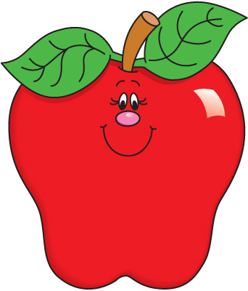 | Yes No

3. | It is a duck? | 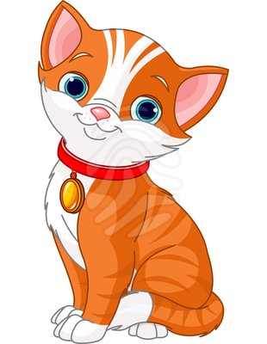 | Yes No

4. | It is a pencil? | 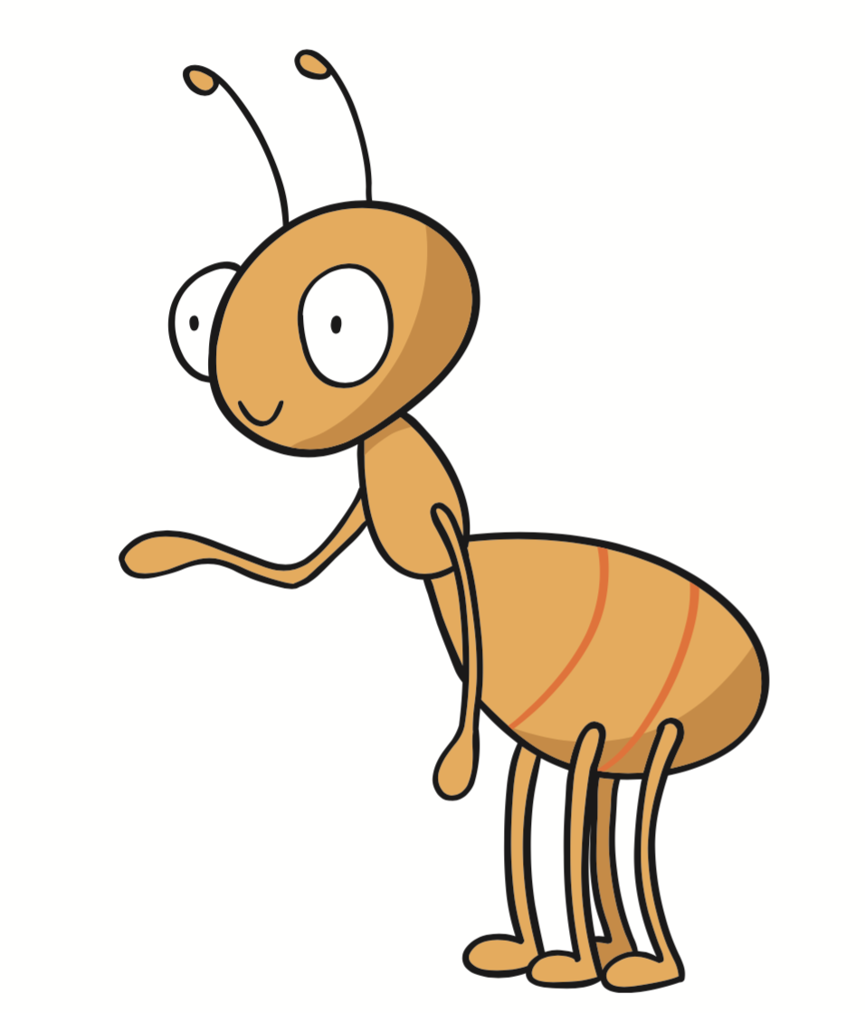 | Yes No
\4

Reading: Part 2
Instruction:
- Read the sentence. Look at the picture.
- Circle the correct answer.

Example | It is a sun. | Aa |  | B | 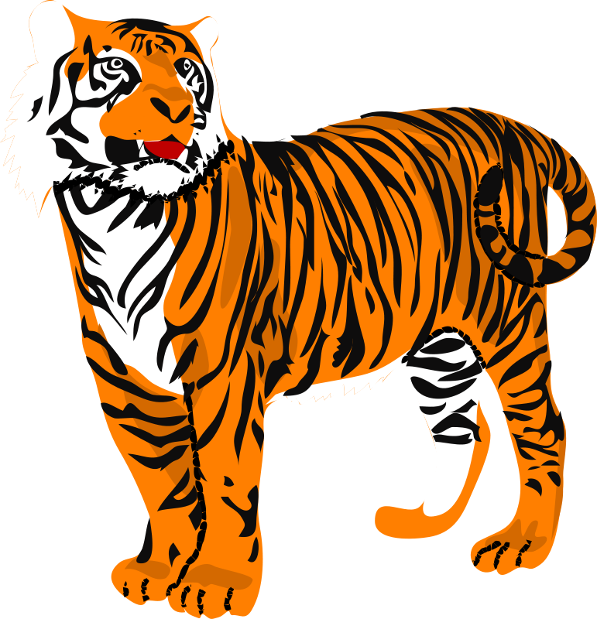

5. | This is a doll. | A |  | B | 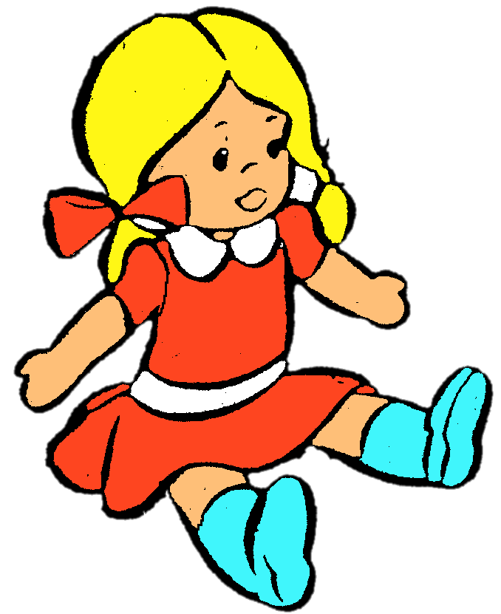

6. | They are triangles. | A |  | B

7. | There are five apples. | A |  | B
\3

Writing: Part 1
Instruction:
- Look ant the picture. Write the missing letters.

Example | _S_ nake | 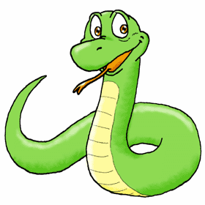

1. | __ iger

2. | __ range | 

3. | __ ouse | 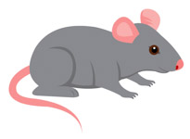

4. | __ even | 7

5. | __ nt


6. | __ ea

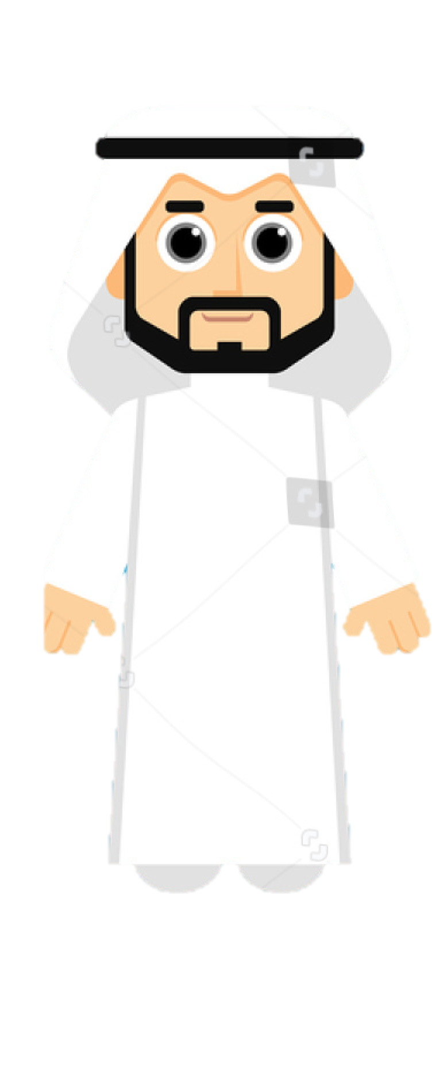

7. | __ ad

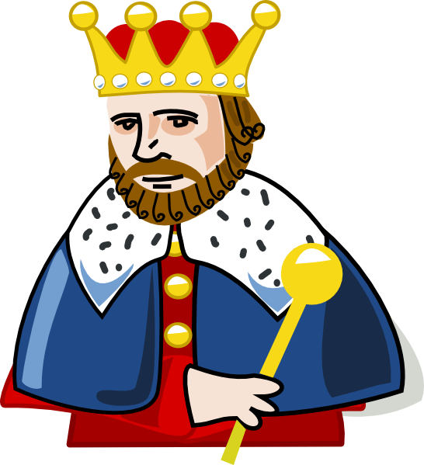
8. | __ ing

\8

