

Name…………………………G1 a.b.c
- Read and Color
- Yellow star
- Red heart
- Pink triangle
- Purple square
- Blue diamond
- Green rectangle
- Black circle

________________________________________
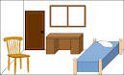
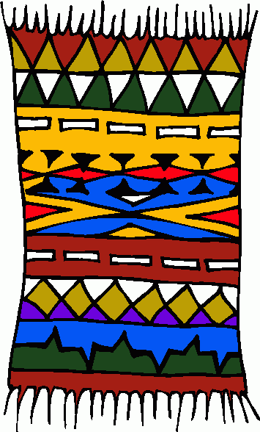
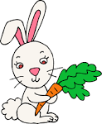
- Write the missing letter.

__ abbit Ru__ Roo__
______________________________________
- Write
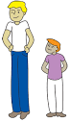
Big Tall small short
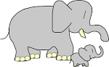

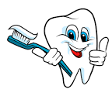
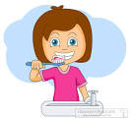
- Match
- Brush your hair
- Wash your face
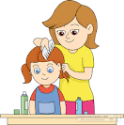

- Brush your teeth
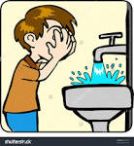
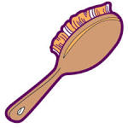

_______________________
- Draw and color .

- Nose
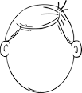
- Two eyes
- Mouth

________________________________________________________
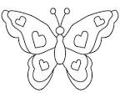
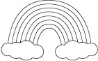
- Color Rainbow butterfly


________________________________________________________________

